Week 10

1. Write a simple shell script to display "Hello, World!" on the terminal.

echo "Hello, World!"



2. Write a shell script to accept user input and display it.

echo "Enter your input:"

read user_input

echo "You entered: $user_input"

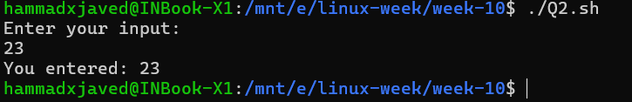

3. Write a shell script to demonstrate the use of variables.

name="Alice"

age=25

echo "Name: $name"

echo "Age: $age"

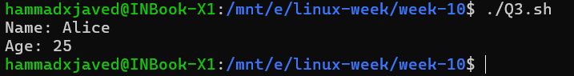

4. Write a shell script to perform basic arithmetic operations.

echo "Enter the first number:"

read num1

echo "Enter the second number:"

read num2

sum=$((num1 + num2))

diff=$((num1 - num2))

prod=$((num1 * num2))

quot=$((num1 / num2))

mod=$((num1 % num2))

echo "Sum: $sum"

echo "Difference: $diff"

echo "Product: $prod"

echo "Quotient: $quot"

echo "Modulus: $mod"

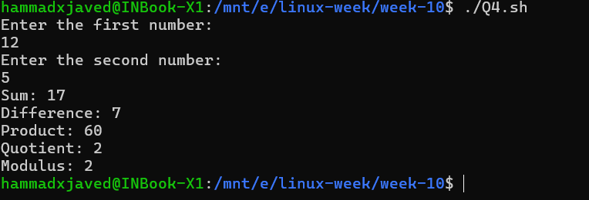

5. Write a program in python to find word/s having maximum number of instances in a

given file and replace all its occurrences with “Aligarh”.

def replace_max_word(file_path):

    with open(file_path, 'r') as file:

        content = file.read().lower()

    word_count = {}

    words = content.split()

    for word in words:

        word_count[word] = word_count.get(word, 0) + 1

    max_word = max(word_count, key=word_count.get)

    print(f"Most frequent word: {max_word} (occurrences: {word_count[max_word]})")

    updated_content = content.replace(max_word+' ', 'Aligarh ')

    updated_content = content.replace(' '+max_word, ' Aligarh')

    with open('updated_file.txt', 'w') as file:

        file.write(updated_content)

replace_max_word('example.txt')

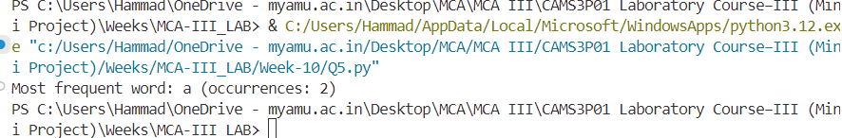

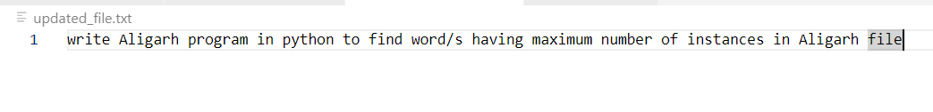

6. Consider two files that contain information about Employees and Departments in the following parameters: Employee (Name, EId, Salary, DID), Department (DID, DName, DLocation). Write a Python program to merge the content of both the file in following format.: Emp_Dep(Ename, Eid, Esalary, EDID, DName,Dlocation) (Note: Merging should follow the condition-DID of Employee file should be equal to Department ID of department file)

import pandas as pd

employee_df = pd.read_csv('Week-10\employees.csv')

department_df = pd.read_csv('Week-10\departments.csv')

merged_df = pd.merge(employee_df, department_df, on='DID', how='inner')

merged_df = merged_df.rename(columns={

    'Name': 'Ename',

    'EId': 'Eid',

    'Salary': 'Esalary',

    'DID': 'EDID',

    'DName': 'DName',

    'DLocation': 'DLocation'

})

print(merged_df)

merged_df.to_csv('Emp_Dep.csv', index=False)

